Intestinal susceptibility artifacts in low field MRI due to oral ingestion of Ferrous Sulphate – Two cases reports

Case Report

ABSTRACT
The Magnetic Susceptibility Artifacts (MSA) generally results from the presence of metallic materials, and they commonly occur due to surgical clips, fragments of projectiles, orthopedic plates, among others. However, reports regarding MSA caused by oral substances ingested are quite rare. It is intended to expose two rare cases of intestinal MSA seen on magnetic resonance images (MRI), in which patients were taking an oral ferrous sulfate supplementation - believed to be the most plausible explanation for the artifacts.
Keywords: Artifacts; Magnetic Resonance Imaging; Ferrous Sulfate.
1.1 INTRODUCTION
Magnetic Resonance Imaging (MRI) often suffers interference from artifacts that degrade the images that may interfere in diagnosis (1-3). Techniques and devices have been developed to minimize several types of these phenomena (4), however magnetic susceptibility artifacts (MSA) are still quite prevalent.
MSA generally results from the presence of metallic materials implanted in the patient’s body in or near the MRI field of view. Usually it presents as a hypointensity focal area that corresponds topographically to the place ferromagnetic material, surrounded by consecutive halos of hyper and hipointensity, also associated to anatomical distortion of nearby organs and structures (5).
Although well known, MSA may lead to diagnostic pitfalls, once it eventually hide or even simulate pathological findings (1). They most commonly occur due to surgical clips, fragments of projectiles, orthopedic plates, and orthodontic appliances, among others (6, 7). Tattoos and permanent makeup has also been reported as a cause of the phenomenon (8). However, reports regarding MSA caused by oral substances ingested are quite rare (6). It's beyond the scope of this article the physical explanation for the phenomenon of MSA, which can be found in details in the literature (5, 9, 10).
This paper exposes two cases of diffuse intestinal MSA identified on patients' abdominal MRI. They both were making usage of an oral supplementation with ferrous sulfate in an outpatient basis, so the authors believe this to be the most plausible explanation for the artifacts.
Besides the rarity of intestinal location, all tests were conducted in low-field MRI (0.35 T), from which one should expect a lower intensity and frequency of the effect of susceptibility, in comparison to the high-field (5). There hasn’t been any similar report in the literature on low-field MRI.
The reports have been approved by the Institutional Review Board (without patient informed consent) of the Universidade Federal da Paraíba - institution where they took place.
1.2 CASES REPORTS
Case 01: female patient, 74 years old, previously diagnosed with malignant rectal tumor, not surgically treated. She had refused surgical therapy and, according to clinical records, was not eligible to undergo chemotherapy. Current complaint was a nonspecific diffuse abdominal pain. She underwent abdominal MRI without IV contrast (patient refused consent to injection). In addition to the MSA (Fig. 1), findings not shown here included irregular rectal thickening with blurring of posterior vaginal wall and an edema in fibro-fatty planes of the pelvis, particularly pre-sacral, probably due to actinic changes after radiotherapy.
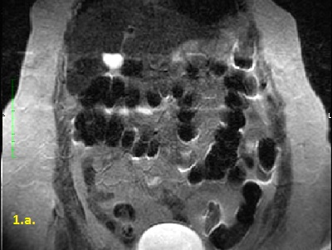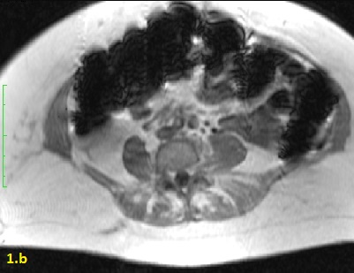
Fig. 01. Case 01. a. Coronal T2 TSE: MSA are seen as several inner hyperintense and outer hyperintense intersected curved bands, protruding diffusely from intestinal lumen and walls (arrows), predominantly in the colon, causing distortion and blurring of their contours. b. Axial T1 in phase: blurring and distortions are more intense and surpass limits of transverse colon through abdominal wall muscles and subcutaneous fat (arrows).
Case 02: female, 31 years, with prior personal history of benign ovarian cyst, complaining of diffuse pelvic pain, who undergone MRI of the pelvis without IV contrast. Not shown in images, a circumscribed cyst of 1,6 cm was found in left ovary, with intermediate signal in T2, that was hyperintense in T1, not attenuated in the sequences with fat suppression. MRI diagnosis was not conclusive and hypothesis included mucinous or hamatogenous contents, such as a hemorrhagic luteal cyst or an endometrial cyst. Follow up imaging was not done. Findings are shown in fig 2.
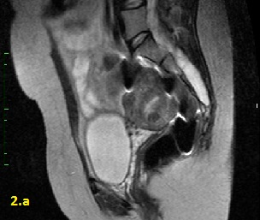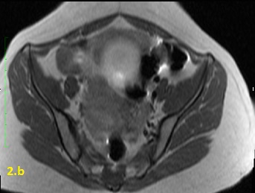
Fig. 2. Case 2. a. Mid sagittal TSE T2. The same hyperintense bands as seen as in case case 1 (fig 1), albeit less prominent, distorts rectum-sigmoid wall borders (arrows). The same effect is present in T1 TSE images in axial plane (b) (arrow).
Exams were done at the same facility in a low-field (0.35 T) open MRI (Magneton C! Siemens, 2011), using its medium size body coil. A single radiologist with experience of more than 10 years performed analysis. MRI parameters in axial T1 (In phase) were a) TR 154ms, TE 3.55/10.30ms (1st and 2nd echo), 90º angle, thickness 8.50mm (30% of gap), FOV 330mm; b) in axial T2 were TR 1690ms, TE 122ms, thickness 6.00 mm (15% of gap), FOV 360mm and angle of 180° angle; c) in coronal T2 were TR 1760ms, TE 182ms, thickness 6.50 mm (20% of gap), FOV 380mm, angle of 180° angle. In all a 256 matrix was used.
Findings of MSA were similar in both cases in all sequences, most noticeable in T1 in-phase, and consisted of prominent diffuse intraluminal low signal throughout the colon and to a lesser extent in some small bowel loops. In several segments there were also artifactual distortion of intestinal wall, with hypo and hyperintense intersected halos and bands surrounding this effect. This findings were more conspicuous in the first patient, in whom artifacts coming from adjacent transverse colon blurred anterior abdominal wall. Physiological intraluminal content can also be hypointense, due to gas and dried stool, but is not accompanied by any imaging phenomena out of the limits of bowel walls, and that sign was assumed as diagnostic of MSA.
Patients were retrospectively asked about foods and medications ingested in the preceding days. Among several items listed, both of them had prescriptions of oral iron supplementation with ferrous sulphate solution (Combiron ®), taken 120mg/day.
1.3 DISCUSSION
Academic reports of MSA due to ingestion of ferromagnetic substances are scarce (6). In an extensive search with diverse descriptors (in example of "Magnetic Fields"/"Magnetic Phenomena"/"Magnetic Resonance Imaging"/"Magnetic" and "Susceptibility") only one case report (6) presented a MSA due to ingesting iron suplement - a homeopathic supplement, consisted mostly of magnetite FeFe2O4 as active ingredient. The authors have not mentioned the magnetic field they have used in imaging. No reports of MSA have specified low-field MRI.
As described, MSA are expected to be more prominent in high-field devices (5). Indeed, low-field MRI has been used to guide interventional procedures due to better visualization of ferromagnetic surgical materials, as it generates a lesser amount of MSA. Low-field MRI (0.2 T) demonstrated superiority when compared to high-field machines in viewing needles, enabling greater clarity and focus to the image studied (11).
Also important to point is that MSA is usually caused by a well-defined focus of paramagnetic metallic materials. The diffuse intra-intestinal distribution of intraluminal MSA make the origin of the findings less obvious to radiologists and raises its potential to induce mistakes (12). In these specific cases the radiologist had pointed to the right diagnosis of MSA at first, what prompted him to search clinically for causes afterwards.
The authors conducted a simple experiment with ferrous sulphate, in order to confirm its capacity to generate MRI artifacts. In plastics bags of 20 cc, pure water and mixes of water and ferrous sulphate solution (Combiron®) in different proportions (up to 50%) underwent the same imaging sequence gradient T1 in and out-of-phase, with the same body coil as in both patients. The bags were put in a bigger plastic bottle of 5.000 cc filled with water, in order to grossly simulate a intestinal loop inside the abdominal cavity. Findings were more prominent at dilution of 50/50% (Fig. 3) and were similar to those artifacts described in the patients. In bags with smaller concentrations, these findings became progressively less evident and finally not present at all with pure water.
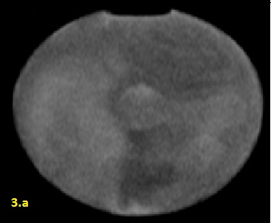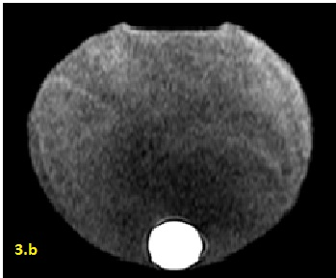
Fig. 3. Ferrous sulphate solution experiment. Axial plane of a 5000 cc bottle filled with water and 20 cc plastic bag inside imaged with the same T1 in phase sequences as the patients. a. Bag containing pure water is floating in the middle of the bottle (circle). As expected, no difference in signal is shown between bag content and water in the bottle. In b, bag contains 50/50% of water and ferrous sulphate solution; it is now deposited in the most dependent part of the bottle for gravitational reasons, showing hyperintense inner signal and thin peripheric halos (inner dark and outer bright) that surpasses its boundaries (arrows), similar to those described in patients. Inner hyperintensity here is different of hypointensity intestinal contents probably due to predominance of low signal of feces in addition to dehydration of ferrous solutions as it passes trough bowel.
Technical resources can be applied to mitigate MSA (13). Turbo Spin Echo (TSE) are preferred, since Gradient Echo (GE), since the latter are more susceptible to artifacts (5). The images presented here corroborate the literature regarding this idea, since In and out-of-phase are GE sequences. Other options include decreasing voxel size, shortening echo time and increasing bandwidth (4, 12).
Ferrous sulphate is widely used as supplement in iron deficiency anemia, the most common hematological abnormality, affecting approximately 20-30% of the world population (14). It is therefore surprising that intra-intestinal MSA reports are yet rare and that it is not a routine finding on daily practice. Possible explanations for these findings being noticed only in such selective cases may include the inadequate intake of overdoses and absorptive disorders that would promote greater intraluminal drug concentration. The predominance of the findings in the colons of patients presented here suggests accumulation of the drug in the stools. These are issues to be tested in future studies.
Bowel MSA can also be caused by foreign body ingestion. However intake of oral medications or nutritional supplements with ferromagnetic elements should always be considered when findings are present in several loops at the same time.

1.4 REFERENCES
1. Alvarenga F, Nobeschi L. Artefatos nas imagens de Ressonância Magnética relacionados ao paciente. Revista Radiologia Brasileira. 2012.

2. J F, D D. Artefatos. In: Medsi, editor. Diagnóstico por imagem em ressonância magnética. 2ª ed. ed. Rio de Janeiro2000. p. 44-51.

3. Mazzola A. Ressonância Magnética: Princípios de formação da imagem e aplicações em imagem funcional. Revista Brasileira de Física Médica. 2009:117-29.

4. Viviane Vieira F, Giuseppe D, ippolito, Gláucia Palácio De Andrade ES, Alexandre Sérgio De Araújo B, Jacob S. Prevalência de artefatos em exames de ressonância magnética do abdome utilizando a seqüência GRASE: comparável com as melhores seqüências rápidas? Prevalence of artifacts in abdominal magnetic resonance imaging using GRASE sequence: a comparison with TSE sequences. Radiologia Brasileira. 2005;38(5):323.

5. Glaucia Andrade ESP, Viviane Vieira F, Cristiane Lima A, Dario Ariel T, Giuseppe D, ippolito, et al. Artefatos em ressonância magnética do abdome: ensaio iconográfico. Radiologia Brasileira. 2002;35(6):371.

6. Taketomi-Takahashi A, Tsushima Y, Nakajima T, Takano A, Amanuma M, Endo K. Magnetite Ingested as a Nutritional Supplement: Unexpected Source of MRI Susceptibility Artifact. AJR. 2007;188:1026-7.

7. Grieve JP, Stacey R, Moore E, Kitchen ND, Jager HR. Artefact on MRA following aneurysm clipping: an in vitro study and prospective comparison with conventional angiography. Neuroradiology. 1999;41(9):680-6.

8. Tope WD, Shellock FG. Magnetic resonance imaging and permanent cosmetics (tattoos): Survey of complications and adverse events. Journal of Magnetic Resonance Imaging. 2002;15(2):180-4.

9. Bonati C, elia M, Mariti M, Negro F, Sanfilippo F, Elia M. Magnetic susceptibility of strongly interacting matter across the deconfinement transition. Physical review letters. 2013;111(18):182001.

10. Hecht S, Adams WH, Narak J, Thomas WB. MAGNETIC RESONANCE IMAGING SUSCEPTIBILITY ARTIFACTS DUE TO METALLIC FOREIGN BODIES. Vet Radiol Ultrasound. 2011;52(4):409-14.

11. Frahm C, Gehl HB, Melchert UH, Weiss HD. Visualization of magnetic resonance-compatible needles at 1.5 and 0.2 Tesla. Cardiovasc Interv Radiol. 1996;19(5):335-40.

12. Arena L, Morehouse HT, Safir J. MR imaging artifacts that simulate disease: how to recognize and eliminate them. Radiographics : a review publication of the Radiological Society of North America, Inc. 1995;15(6):1373-94.

13. C W, C K. Ressonância magnética prática. Artefatos e sua compensação. 2ª ed. ed. Rio de Janeiro.2000.

14. Cançado R, Chiattone C. Anemia ferropênica no adulto - causas, diagnóstico e tratamento. Rev Bras Hematol Hemoter. 2010:240-6.

